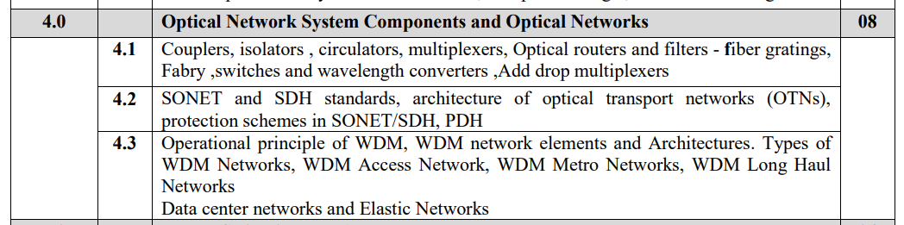

**WDM:**

• WDM (Wavelength Division Multiplexing) corresponds to the scheme in which multiple optical carriers at different wavelengths (produced by LASER) are modulated by using independent electrical bit streams (which may themselves use TDM and FDM techniques in the electrical domain) and are then transmitted over the same fiber.

• The optical signal at the receiver is demultiplexed into separate channels by using an optical technique.

• The main system feature of WDM are as follows:

1. Capacity
2. Transparency
3. Wavelength routing
4. Wavelength switching

• There are two types of WDM

i. Unidirectional

ii. Bidirectional

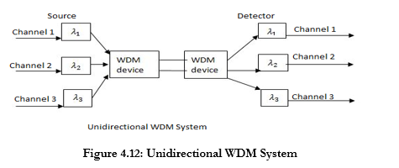

• In unidirectional WDM system Single Carrier wavelengths are fed into single fibers at one end and then separate them into their corresponding detectors at other end.

• The insertion loss, channel width and cross talk are the three basic parameters which are used to decide the performance of a WDM system.

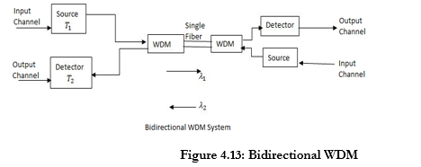

**System**

• The bidirectional WDM technique enables bidirectional communications over one strand of fibre, as well as multiplication of capacity.

• WDM systems are divided in different wavelength patterns, conventional or coarse and dense WDM.

• Conventional WDM systems provide up to 8 channels in the 3rd transmission window (C-band) of silica fibres around 1550nm. Dense WDM uses the same transmission window but with denser channel spacing.

**Advantages of WDM**:

Wavelength division multiplexing has several advantages over the other presented approaches to increase the capacity of a link:

• Works with existing single mode communication fibre

• Works with low speed equipment

• Is transparent: Doesn’t depend on the protocol that has to be transmitted.

• Is scalable: Instead of switching to a new technology, a new channel can easily be added to existing channels. Companies only have to pay for the bandwidth they actually need.

• It is easy for network providers to add additional capacity in a few days if customers need it. This gives companies using WDM an economical advantage. Parts of a fibre can be leased to a customer who then gets fast network access without having to share the connection with others. The telecommunication company on the other hand still has an independent part of the fibre available for other customers.

**Architecture of WDM**:

i. The general architecture of wavelength routing mesh network is as shown in figure 4.24:

ii. The different WDM network elements like Optical Line Terminals (OLT), Optical Add Drop Multiplexer (OADM), and Optical Cross Connects (OXC) etc. are shown in the architecture.

iii. OLTs are placed either at the end of links or in point-to-point configurations. OADMs are used at places where some fractions of the wavelengths need to be terminated and others need to be added and are typically in linear or ring topologies.

iv. OXCs enable mesh topologies and switching of wavelengths. Clients of these networks can be ATM, SONET, IP switches using the optical layer.

v. Network supports a variety of client types, such as IP routers, ATM switches, and SONET terminals and ADMs.

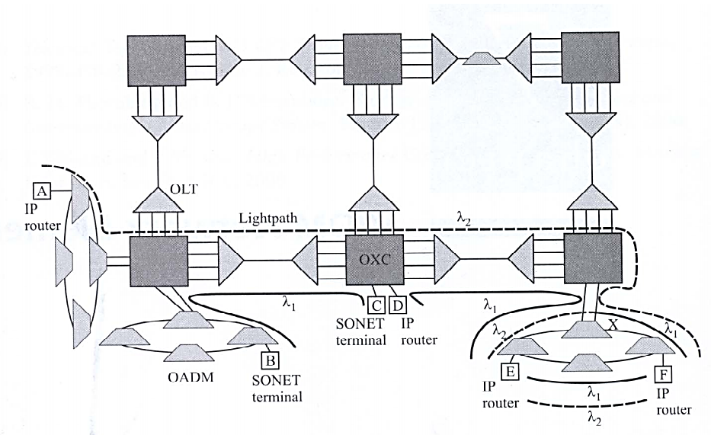

Fig4.24: Architecture of wavelength Routing mesh

**Optical Line Terminals (OLT)**:

i. They are used at either end of a point-to-point link to multiplex and demultiplex wavelengths.

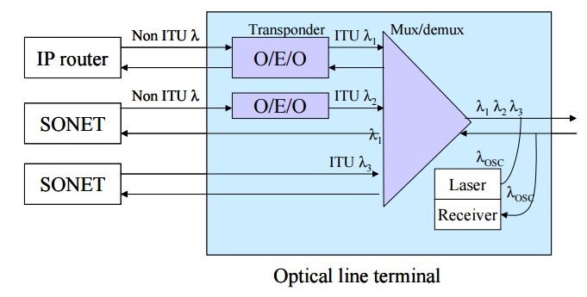

Fig 4.24(a): Optical Line Terminal

ii. Three functional elements inside an OLT: transponders, wavelength multiplexers, and optionally, optical amplifiers.

iii. A transponder adapts the signal coming in from a client of the optical network into a signal suitable for use inside the optical network.

iv. Likewise, in the reverse direction, it adapts the signal from the optical network into a signal suitable for the client.

v. Interface between the client and the distance and loss between the client and the transponder.

vi. The most common interface is the SONET/SDH short - reach (SR).

**Optical Add/Drop Multiplexers (OADM)**:

i. Optical add/drop multiplexers (OADMs) provide a cost-effective means for handling pass-through traffic in both metro and long-haul networks. „

ii. OADMs may be used at amplifier sites in long-haul networks but can also be used as stand-alone network elements, particularly in metro networks.

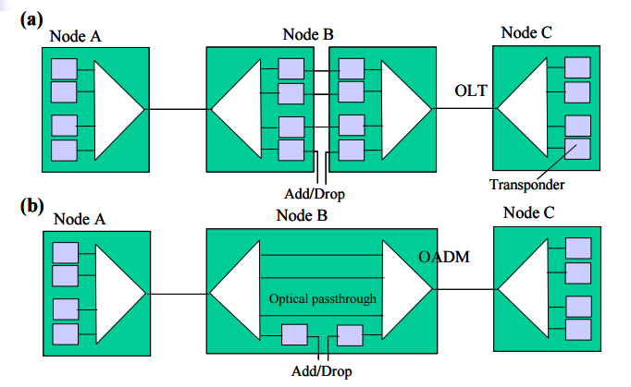

Fig4.25: Three node linear network examples

iii. In figure 4.25, three node linear network examples to illustrate the role of optical add/drop multiplexers.

iv. Three wavelengths are needed between nodes A and C, and one wavelength each between nodes A and B and between nodes B and C.

4.25(a): Solution using point-to-point WDM systems.

4.25(b): Solution using an optical add/drop multiplexer at node B.

**Parallel OADM Architecture**:

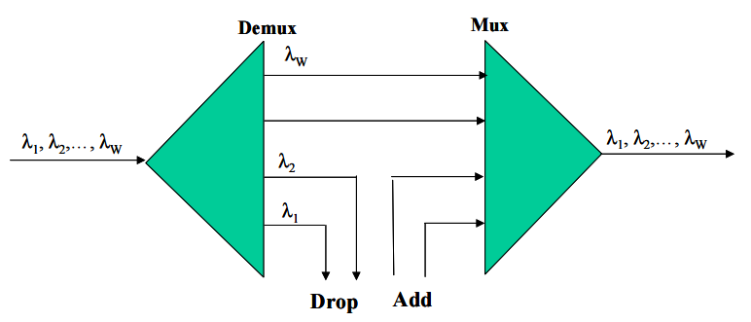

Fig4.26 (a): Parallel OADM Architecture

i. No constraints on what λ-s can be adropped (minimal constraints on planning lightpaths).

ii. Loss is fixed not cost effective if adropping small number of λ-s. Since all λ-s are always re-multiplexed, the tolerance of lasers/filters must be stringent.

**Modular Parallel OADM Architecture**:

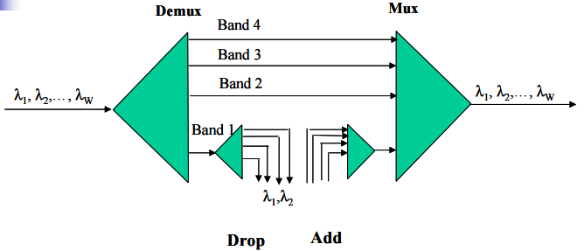

Fig 4.26(b): Modular Parallel OADM Architecture

i. Implies constraints on what λ-s can be adropped. Cost effective also if adropping small number of λ-s.

ii. The tolerance of lasers/filters can be higher. Loss is fixed (adropping additional channels is easy). Loss is not uniform for all λ-s.

**Serial OADM Architecture**:

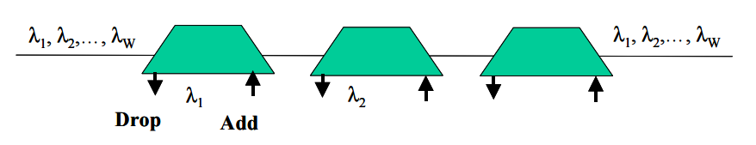

Fig 4.26(c): Serial OADM Architecture

i. A single channel is adropped (SC-OADM). To drop multiple channels, SC-OADMs can be cascaded.

ii. Adding additional SC-OADMs disrupts existing channels for a short while, thus planning is needed ahead of time.

iii. Highly modular (cost is low for less λ-s). Loss increases with λ-s to be adropped which may require additional OLAs.

**Band-drop OADM Architecture**:

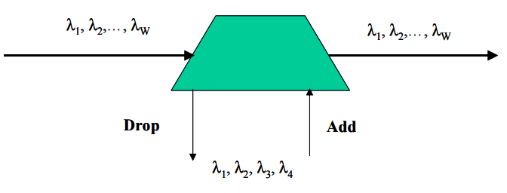

Fig 4.26(d): Band-drop OADM Architecture

Fixed group of λ-s is adropped and undergo a further level of demultiplexing. Adropping additional λ-s does not affect loss (if this λ-s are in the group).

**Optical Cross connects (OXC)**:

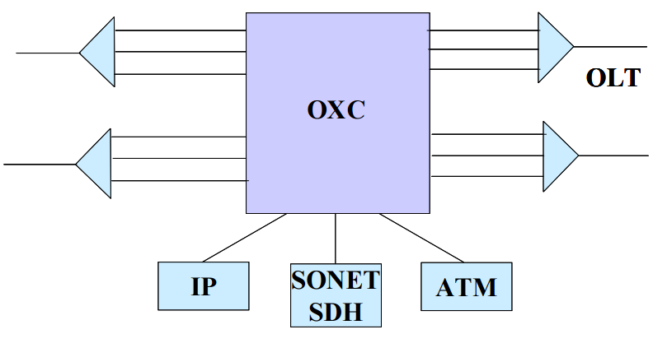

Fig 4.27: A Typical OXC

i. OXCs are required to handle mesh topologies (OADMs have only two ports making them available for ring and point-to-point only).

ii. OXC are also key elements for reconfigurability. Some ports are connected to other OXCs and some are terminated by optical layer client equipment (SONET, ATM, etc.). OXCs usually do not contain OLTs (separate products).

WDM Access Networks:

WDM is a technology that enables various optical signals to be transmitted by a single fiber. Its principle is essentially the same as Frequency Division Multiplexing (FDM). That is, several signals are transmitted using different carriers, occupying non-overlapping parts of a frequency spectrum. In case of WDM, the spectrum band used is in the region of 1300 or 1550 nm, which are two wavelength windows at which optical fibers have very low signal loss.

With the advancement in technology, over 100 optical channels can be multiplexed into a single fiber. The technology was then named dense WDM (DWDM).

WDM in the Long Haul

In 1995, long-distance carriers in the United States started using WDM systems to boost their network capacities without laying new fiber. Since then, WDM has rapidly become popular in the long-distance market. WDM helps manage growing capacity needs and delays the need for more fiber, offering flexibility for upgrades.

WDM is cost-effective compared to other solutions like enhanced Electrical Time Division Multiplexing (TDM) for network upgrades. The "open" WDM setup uses transponders in WDM multiplexers and shared optical amplifiers for multiple wavelength channels.

The transponder is in essence a 3R opto-electro-optic (O/E/O) converter, that converts an optical signal into an electrical signal (and vice versa) while repowering, reshaping and retiming the signal electrically. Upgrading to higher Electrical domain TDM rates (e.g., from 2.5 Gb/s STM-16 to 10 Gb/s STM-64) is only a short-lived solution since transmission impairments such as dispersion do not scale well with increasing TDM rates, especially on standard single-mode fiber.

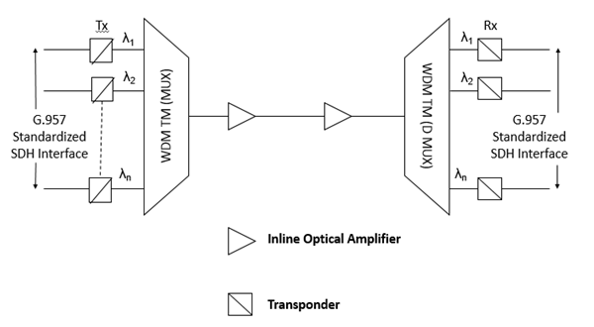

A case study found that long-distance point-to-point WDM systems are cheaper than using three STM-16 channels. The study compared costs for a network's core spanning 5000 kilometers with an average distance of 300 kilometers between access cities.

The study showed that initially, WDM setup costs more than twice as much as using SDH (Synchronous Digital Hierarchy) equipment. However, for networks needing three channels or more, WDM becomes more cost-effective due to sharing optical amplifiers.

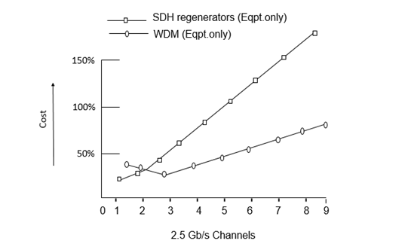

Considering fiber costs along with other factors, the cost advantage of using WDM becomes even clearer, especially as the number of channels increases. WDM is more cost-effective when deploying three channels or more in the network.

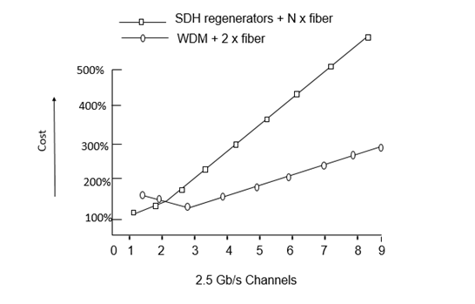

WDM in the Short Haul

Regenerators are not necessary in short-haul networks because distances are limited, making optical issues less of a problem compared to electrical TDM. But now, with fiber scarcity and cheaper optical parts, WDM is gaining traction in cities.

Short-haul networks connect various Points of Presence (POPs) within a city. For example, a city's transport network may have at least two POPs where customers can connect. Using dual node interconnection methods like drop and continue, customer networks can link up with the transport network via different POPs, ensuring robustness even if one POP fails.

This setup ensures secure traffic flow within a city, not just through it. This increased need for intra-city capacity has driven the adoption of WDM in short-haul transport networks.

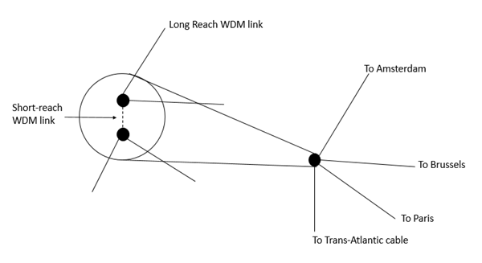

The main reason WDM is preferred because leasing or building city fibers is expensive and inflexible for capacity upgrades. Predicting the amount of fiber needed in a rapidly evolving traffic environment is difficult. WDM offers flexibility as wavelength channels can be activated quickly.

While specific short-haul WDM systems exist, it's advantageous to use the same type of WDM system for both short and long-haul networks. Short-haul WDM systems are cheaper and use low-cost optical components, but having different systems creates a heterogeneous network. This leads to higher operational and management costs due to the need for more spare parts. Additionally, interoperability issues may arise, such as bottlenecks because short-haul WDM systems typically support fewer wavelengths than long-haul ones.

## ****Optical Transport Network:****

A set of Optical Network Elements connected by optical fiber links, able to provide functionality of transport, multiplexing, switching, management, supervision and survivability of optical channels carrying client signals.

OTN is used because of following reasons;

• Operators’ need to use existing fiber to satisfy Growing demand for services and bandwidth.

• DWDM increased fiber bandwidth, but lacked protection and management capabilities.

• OTN combines the benefits of SONET/SDH with DWDM.

Figure shows the format of the synchronous OTN frame.

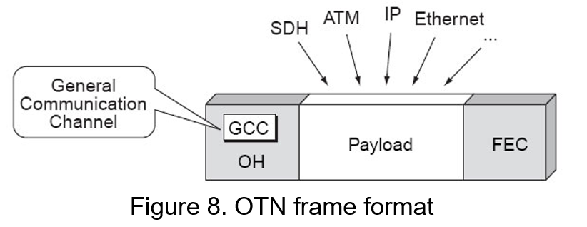

All types of frames are to be transported transparently in the OTM frame, without them having to be modified. A field is expected to add an FEC (Forward Error Correction) to perform the necessary corrections to achieve an error rate determined.

OTN interface consists of several levels. Starting from the optical fiber with the following layers are:

1. OTS (Optical Transmission Section), which supports signal transmission optical checking its integrity.
2. OMS (Optical Multiplex Section), which supports features to provide a wavelength-division multiplexing.
3. OCH (Optical Channel), which is the level of one end of the optical signal. This level allows modification of the connection and rerouting, and maintenance functions to the connection.
4. In order to get access for end-to-end networking of optical channels to transparently convey user information, the OCh layer is employed in the OTN structure. It also ensures connection rearrangement for flexible routing. Either full or reduced optical channel availability can be employed as required.
5. DW (Digital Wrapper), which corresponds to the digital envelope. The level Digital Wrapper itself is broken down into three levels:
6. OTU (Optical Transport Unit), which gives the possibility of adopting a correction using FEC.
7. The OTU layer gives additional functionality by adding forward error correction to the network elements and by allowing carrier operators to reduce the number of optical devices and switches used in the network (i.e. amplifiers, multiplexers, 3R regenerators). It also encapsulates two additional layers, the optical channel data unit (ODU) and the optical channel payload unit (OPU).
8. ODU (Optical Data Unit), which manages connectivity regardless of clients and offers protection and management of this connectivity. The ODU layer provides client-independent connectivity, connection protection and monitoring whereas the OPU enables access to the payload information of SDH/SONET signals.
9. OPU (Optical Payload Unit), which indicates a match between the signal and the type of client. The overall architecture of OTN is shown in Figure.

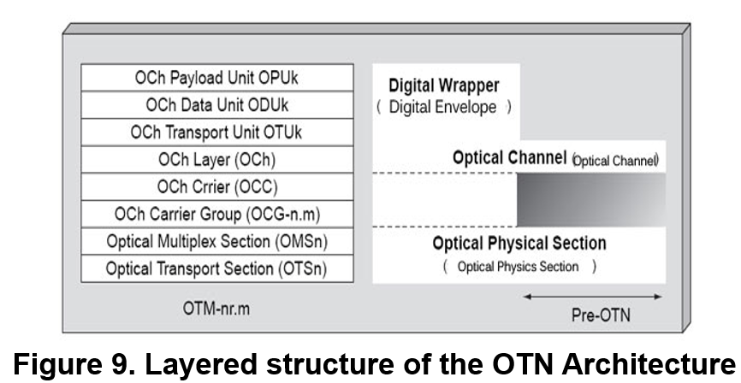

1. The OTN hierarchy to support these four layers may also include three sections as, which are: the optical transmission section (OTS); the optical multiplexing section (OMS); the optical physical section (OPS).
2. Different physical sections of the OTN are interfaced based on the information obtained from OTS, OMS and OPS, respectively.
3. OTS provides the required information about optical transmission functionality for optical signals to travel through optical fibers and the necessary switching operation at fiber end points.
4. The optical multiplexing section (OMS) gives the means of networking for a multiwavelength optical signal, whereas the OPS describe the optical characteristics of the physical section in order to provide reduced functionality excluding those sections which are not required to establish an interface between two domains.

**Advantages:**

• Protocol transparency, Integrity of the client signal is maintained, end user views exactly what was transmitted.

• Backward compatibility for existing protocols.

• Better switching scalability, OTN is able to switch at a higher bit rates than SDH.

• Better Forward Error Correction (FEC).